**Test Case 10**

**System:** Bench

**Description:** Black box testing to check email registration for notifications.

**Severity:** 2

**Instructions**

**Test 1**

1. Start the Bench application.
2. Click the button “Login” on the navigation bar.
3. Enter the email “team23project@gmail.com” into the text field labeled “Email address”.
4. Enter the password “12345678” into the field labeled “Password”.
5. Click the button “Login” below the field.
6. After the screen has loaded, click on the button “My Profile” on the navigation bar.

**Expected Result:** There should be a notification panel on the page where the user is allowed to enter their email registration for the notifications.

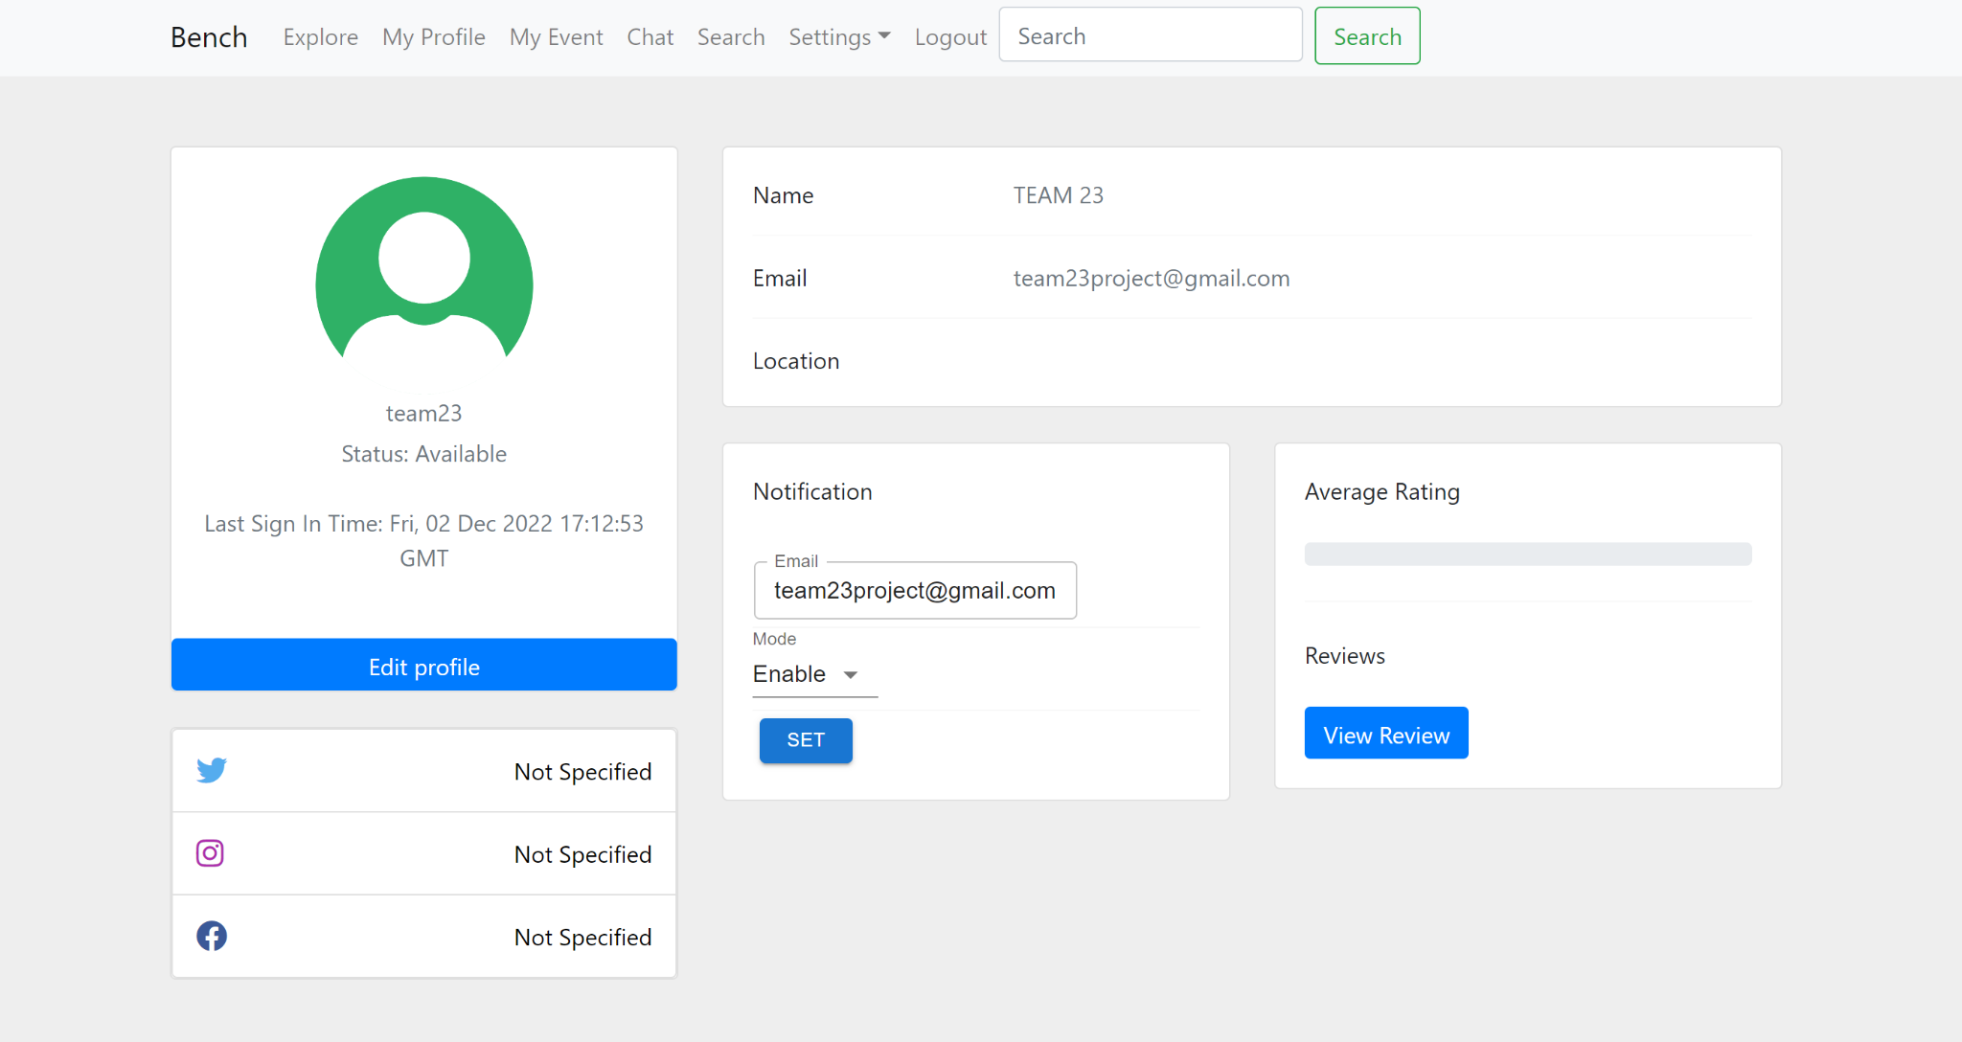

**Test 2**

1. Start the Bench application.
2. Click the button “Login” on the navigation bar.
3. Enter the email “team23project@gmail.com” into the text field labeled “Email address”.
4. Enter the password “12345678” into the field labeled “Password”.
5. Click the button “Login” below the field.
6. After the screen has loaded, click on the button “My Profile” on the navigation bar.
7. Enter an email address into the email input field in the notification panel.
8. Click the button “Enable” in the dropdown menu.
9. Click the button “Set”.

**Expected Result:** There should appear an alert indicating that the new registered email has been stored into the database.

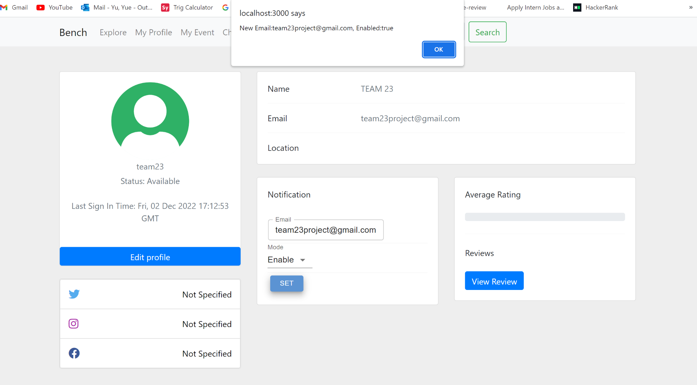

**Test 3**

1. Start the Bench application.
2. Click the button “Login” on the navigation bar.
3. Enter the email “team23project@gmail.com” into the text field labeled “Email address”.
4. Enter the password “12345678” into the field labeled “Password”.
5. Click the button “Login” below the field.
6. After the screen has loaded, click on the button “My Profile” on the navigation bar.
7. Enter a different email address into the email input field in the notification panel.
8. Click the button “Enable” in the dropdown menu.
9. Click the button “Set”.

**Expected Result:** This means that the user is allowed to change email registrations for notifications as many times as they want.

